Kiren Rijiju (Union Minister of Parliamentary Affairs and Minority Affairs)

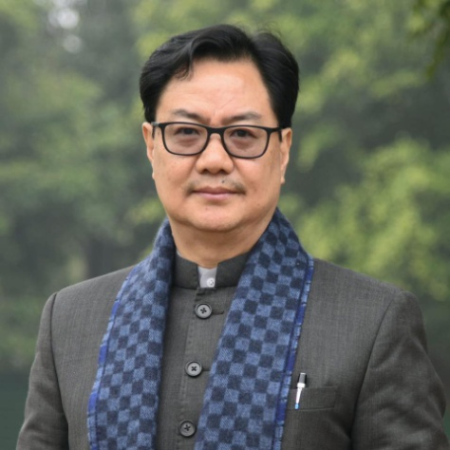**Kiren Rijiju** is a BJP MP and **Union Minister of Parliamentary Affairs** and **Minority Affairs** assumed from 10 June 2024. He belongs to Arunachal Pradesh (West), and becomes a

. He praises the **Act East Policy** launched by PM Modi.

* Ministry of Parliamentary Affairs
* Ministry of Minority Affairs
* First Buddhist as Minority affairs minister
* Arunachal Pradesh
* Arunachal West
* BJP Arunachal
* North East India
* Act East Policy - India's Act East Policy is a foreign policy initiative launched in 2014
* Vibrant Village Program

Mansukh Mandaviya (Union Minister of Youth Affairs and Sports) and (Union Minister of Labour and Employment)

Mansukh Mandaviya is a **Union Minister of Youth Affairs and Sports** and **Union Minister of Labour and Employment** assumed from 11 June 2024 and **Rajya Sabha member** from Gujarat. He belongs to Bhavnagar, Gujarat. His full name is **Mansukh Laxmanbhai Mandaviya**. He won the Election 2024 from the **Porbander** seat. Mansukh Mandaviya inaugurated various Program and Compaign - **Khelo India Rising Team Identification (KIRTI)**

* 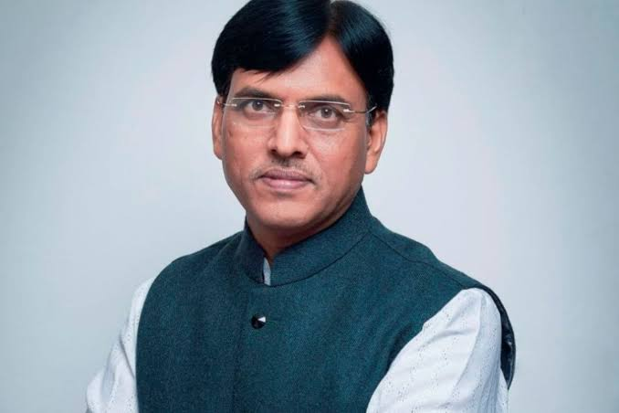Ministry of Youth Affairs & Sports
* Sports
* MY Bharat Platform
* Mera Yuva Bharat Campaign
* Youth Affairs
* Sports Minster खेल मंत्री
* EPFO - Employees Provident Fund Organisation
* ESIC - Employees State Insurance Corporation
* Labour
* Employment
* Porbandar पोरबन्दर - Mansukh Mandaviya won the Election 2024 from the Porbander seat
* BJP Gujarat
* Sport Authority of India
* Khelo India - National Programme for Development of Sports
* Fit India - It is a movement launched by PM Modi to encourage people to remain healthy and fit by including physical activities and sports in their daily lives.
* Department of Sports
* Cheer4Bharat - Mansukh Mandaviya & Bollywood star Ayushmann Khurrana have a special appeal to make to our country - cheer for the Indian contingent to bring glory to our nation at the Paris Olympics 2024
* KIRTI - Khelo India Rising Team Identification
* Ek Bharat Shreshtha Bharat - Hindi can become a language that symbolizes our self-respect in government affairs and brings us closer to the goal of Ek Bharat, Shreshtha Bharat: Dr Mansukh Mandaviya
* ViksitBharat - Viksit Bharat is the current government's roadmap to making India a completely developed nation by 2047.
* SabkaSathSabkaVikas - A campaign launched by central government from Sep 20219. It also known as People’s Plan Campaign.
* Incredible India - A campaign launched by Govt. of India in 2002 to promote tourism in India.\
* \
* Gati Shakti - A project initiative by PM Modi in Oct 2021 to create world-class infrastructure and logistics synergy across different modes of movement.
* Modi Sarkar 3

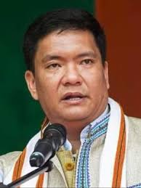Pema Khandu (Chief Minister of Arunachal Pradesh)

BJP Arunachal

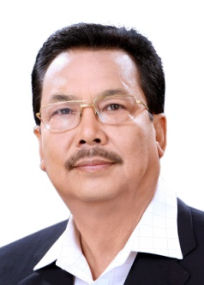Chowna Mein (Deputy Chief Minister of Arunachal Pradesh)

BJP Arunachal